

Chambers of Lawrence Power

4 King’s Bench Walk,

Temple, London, EC4Y 7DL

Tel: 02078228822 Fax: 02078228844

**North Face - Red Faced Apology Over Wikipedia 'Hack'**

[North Face has apologised](https://twitter.com/thenorthface/status/1133903040707059712) for manipulating Wikipedia to boost its Google search results.

The well-known US clothing brand, which emerged from humble beginnings as a retailer of specialist climbing gear, came under sharpcriticism when its new ad campaign [video explaining what it had done](https://adage.com/creativity/work/north-face-top-imagens/2174261), was shared online by Advertising Age.

In the campaign video, North face proudly announced how they had "hacked" the search rankings using Wikipedia pages and it cost "nothing".Furtherboasting how they cleverly noticed; “before going on a trip, everyone does a google search” and “most of the time, the first image is from Wikipedia”, so they “did what no one has done before”.

They photographed models wearing their brand in more than 15 adventurous places, including Brazil's Guarita State Park, as well as California's Cabo peninsula and Scotland's Cuillin mountains. Then in April, with hired help from a Brazilian subsidiary ad agency Leo Burnett Tailor Made, they simply switched the Wikipedia location images for their own branded images. “simple as that” according to the video..

The self-praising video was not well received and experienced a social media backlash whilst The Wikimedia Foundation, which set up and oversees the online encyclopaedia, called the campaign ‘unethically’ manipulating, adding, “what they did was akin to defacing public property,… commercial promotion goes directly against the policies, purpose and mission of Wikipedia to provide neutral, fact-based knowledge to the world.”

North Face was left red faced and duly issued the following apology via Twitter:

"We believe deeply in Wikipedia's mission and apologise for engaging in activity inconsistent with those principles,"

But North Face didn’t stop there, announcing:

“Effective immediately, we have ended the campaign and moving forward, we'll commit to ensuring that our teams and vendors are better trained on site policies.”

Leo Taylor Burnett were also suitably humbled by the online condemnation and stated:

“Leo Burnett Tailor Made found a unique way to contribute photography of adventure destinations to their respective Wikipedia articles while achieving the goal of elevating those images in search rankings. We’re always looking for creative ways to meet consumers where they are. We’ve since learned that this effort worked counter to Wikipedia’s community guidelines. Understanding the issue, we ended the campaign. Our team has further accepted an invitation by Wikipedia to learn more about the platform and their work to share unbiased, fact-based knowledge. We look forward to working with Wikipedia to engage with them, and with respect to their network of volunteer editors, better in the future.”

their reputation. However, a cynic may suggest that the publicity caused by such stunts, the ensuing controversy and attention around it can be part of the overall campaign goal and brand marketing strategy.

So maybe that was the plan all along Now we are all very much more aware, more than ever, of North Face and of course (if you didn’t know them before, you do now), the ad agency Leo Burnett Tailor Made.

© 2019 Emma Connolly

[www.whitestonechambers.com](http://www.whitestonechambers.com)

[law@whitestonechambers.com](mailto:law@whitestonechambers.com)

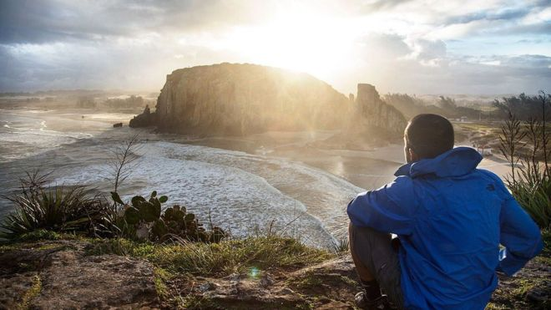

Image copyright Wikipedia Image caption Models were snapped in remote locations and the images added to Wikipedia pages